Network Architecture and Protocol Lab

Booklet 8
Submitted by: Jamil Ahmed
Neptun Code: JZT75Y

4.1

A) On which port number(s) does FTP communicate?
FTP mainly communicates on port 21, which is used for the control connection where commands and responses are exchanged between the client and server. Traditional active-mode FTP also uses port 20 for transferring data. Therefore, FTP commonly uses ports 21 and 20.

B) Which command can we use for filtering a given service name?
The grep command can be used for filtering a given service name from the /etc/services file.
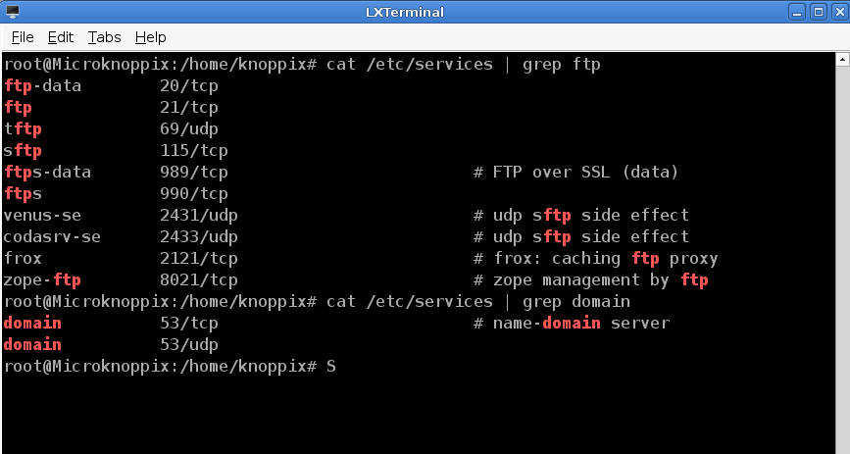

4.2

A) How many Wireshark filter types do you know? Name them.
Wireshark mainly uses two types of filters:
- Capture Filters
- Display Filters
Capture filters are applied before packets are captured, meaning only matching packets are stored. Display filters are applied after capturing and only affect which packets are shown on the screen.

B) How can we make a diagram-based statistical report with Wireshark regarding the captured packets?
Wireshark can generate graphical and statistical reports from captured packets through the Statistics menu. We can use options such as: Protocol Hierarchy, IO Graphs, Conversations, Endpoints
For example, by opening: Statistics → IO Graphs, Wireshark creates a diagram showing traffic volume over time. These graphs help analyze packet flow, protocol usage, and network behavior visually.

4.3

A) How many system states does the Finite State Machine (FSM) contain which manages TCP connection?
The TCP Finite State Machine contains 11 states. These states manage the complete lifecycle of a TCP connection from establishment to termination.
The states are:
- CLOSED
- LISTEN
- SYN_SENT
- SYN_RECEIVED
- ESTABLISHED
- FIN_WAIT_1
- FIN_WAIT_2
- CLOSE_WAIT
- CLOSING
- LAST_ACK
- TIME_WAIT

B) What is the difference between an active and a passive TCP connection termination?
In active termination, the side that initiates the closing process sends the first FIN packet. This device actively requests the termination of the connection.
In passive termination, the other side receives the FIN request and responds with ACK and later sends its own FIN packet. It mainly reacts to the termination request initiated by the active side.
Therefore, the difference lies in which side starts the connection closing procedure first.

4.4

A) Can we use netstat command in Windows environment?
Yes, the netstat command is also available in Windows. It is used for displaying active network connections, routing tables, listening ports, and network statistics similarly to Linux systems.
Example: netstat -an

B) How (using which command and what way) can we determine if we have an active web connection with destination host IP address 193.225.40.94?
We can use the following command:
netstat -ant
Then we check the output for the destination IP address:
193.225.40.94:80
If the connection state appears as ESTABLISHED, it means an active web connection currently exists with that host.

4.5

A) Can we use the netcat tool for implementing a chat program?
Yes, netcat can be used for implementing a simple chat program. One machine runs in listening mode as the server, while another machine connects as the client. After connection establishment, both sides can exchange text messages interactively.
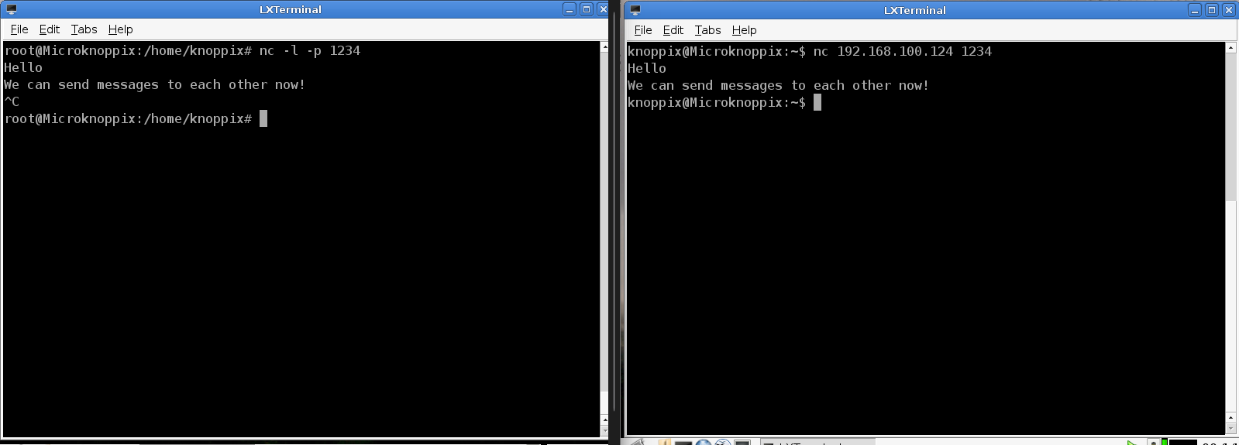

B) How could we block the running of such a chat environment in the most simple way?
The simplest method is to stop the netcat process by pressing the following keys:
Ctrl + C
This immediately terminates the listening or connected session and closes the chat environment.

4.6

A) Can file transfer happen above UDP?
Yes, file transfer can happen over UDP, but UDP does not guarantee delivery, ordering, or error correction. Therefore, additional mechanisms must usually be implemented at the application level to ensure reliable file transfer.
B) In the case of Netcat-based file transfer, is server or client side necessary to implement first? Justify your answer.
The server side must be implemented first because it has to enter listening mode and wait for incoming connections or data. If the client tries to send data before the server is listening, the connection attempt will fail because no process is ready to receive the transmitted file.

4.7

A) Which option can we use for setting the scanned server side in listening mode?
The -l option is used for setting netcat into listening mode. -l means listen mode. -p specifies the port number.
Example: nc -l -p 9999

B) Can we use the netcat tool for scanning several ports which are opened at the same time?
Yes, netcat can scan multiple ports.
Example: nc -zv 192.168.1.10 20-100
This command scans ports from 20 to 100 on the target machine and reports which ports are open.

4.8

A) Can we use nmap port for opening?
No, nmap itself cannot open ports. nmap is a network scanning and analysis tool used for discovering hosts, services, and open ports. Opening a port requires configuring a service or firewall on the target machine, not using nmap.

B) Which port numbers are open on freemail.hu server?
The following port number are open on freemail.hu server:
- 80 (HTTP)
- 110 (POP3)
- 143 (IMAP)
- 443 (HTTPS)
- 993 (IMAPS)
- 995 (POP3S)

